Interface Specification
Skullduggery
Greg Baker - Robert Koeninger
Advisor: Prof. Wilsey
Jan 13, 2010
Revised: Mar 3, 2010

Introduction
The application is being written for the Skullduggery project, which will suppliment the GSM encryption that is currently the standard. The application will have two UI components. The default Android phone call UI will be adapted for the purpose of describing the encrypted call status. The 'settings' menu will be used to set various settings, including encryption method and debugging settings.

During the call
The display during the call will be changed to convey the status of the call. If the call is safely encrypted, we will display a lock, icon or play a sound to inform the user that the call is secure.
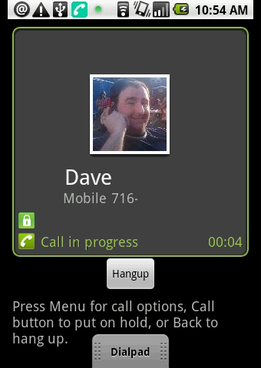Fig 1: A conversation with encryption enabled.
If the encryption methods fail for a lack of ability by the receiver, or other methods, the UI will be changed depending on the specified settings, such as an unlocked red lock, or an intermittent beep.
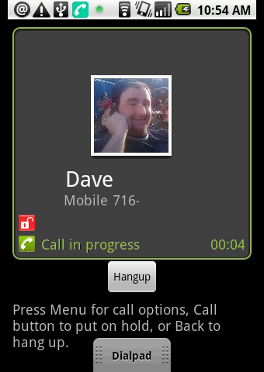Fig 2: A conversation without encryption (Dave doesn’t have Skullduggery).
Settings Menu
Skullduggery will require modification of the Settings menu. This will be performed using the Android libraries. The menu options will be specified as needed, but will likely include alternate encryption methods.
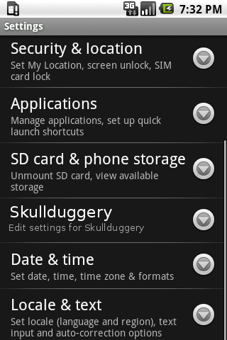Fig 4: A Skullduggery option will be added to the Settings menu
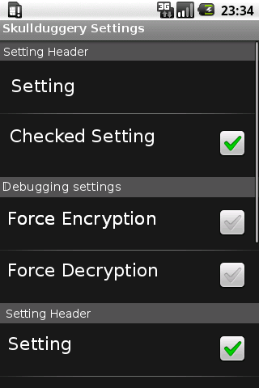Fig 3: The Skullduggery settings will include debugging settings, as well as user-specified settings.

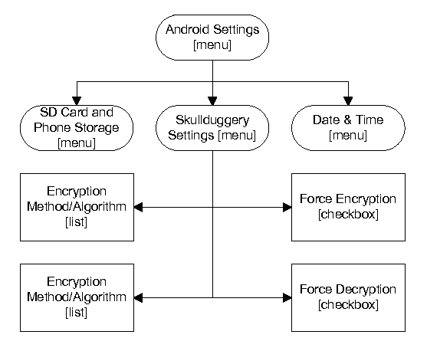
Fig-5: Chart showing the structure of the settings menu. Pre-existing sub-menus are shown toward the top.

